**Project Name:** Field Day Flex

Field Day Flex is a scientific tool that allows the creator to customize their interface to meet their data collection needs. The tool allows the creator to start new projects in which they can add any study subjects they desire, from plants and animals to volcanoes and constellations. Each study subject allows the creator to choose what data will be measured. The creator defines data entry fields for each study subject by defining available choices in a dropdown menu or allowing free entry using a text box. Field day flex can also generate unique identifiers for entries within a study subject for a wide range of use cases.

Figure 1.0 below defines the structure of the document-based database that supports the customizable functionality of Field Day Flex.

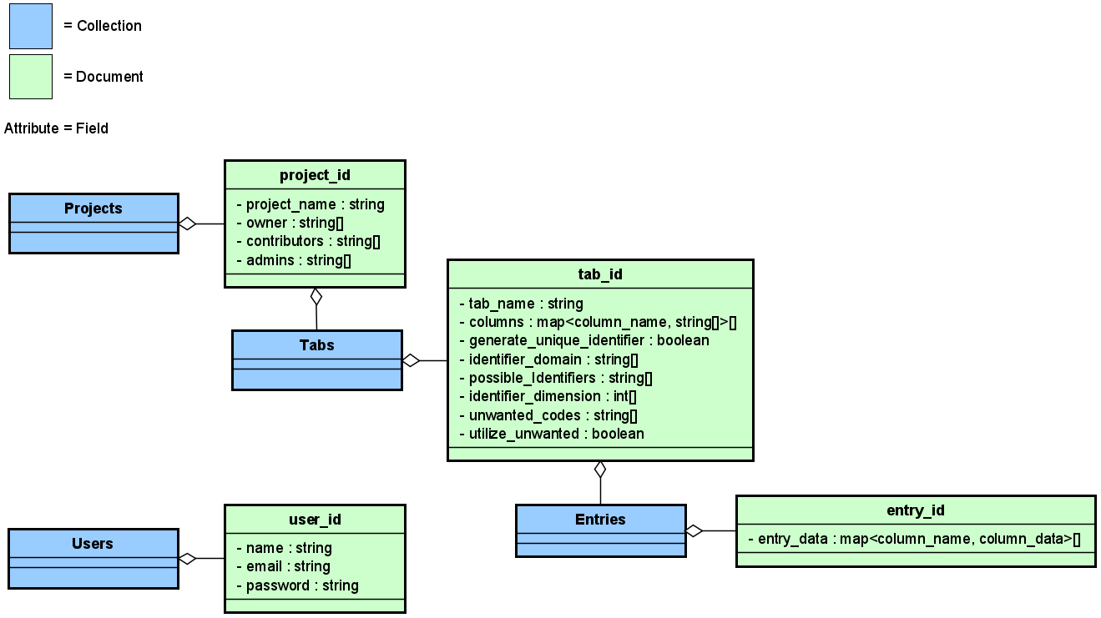

Figure 1.0: Document-based database design.

The database consists of a collection of projects that are created by users. The creator of the project will be an owner listed in a field contained therein. The creator will have the ability to add admins or contributors to the project. Each project contains a collection of Tabs, each of which maps to a desired study subject the creator wishes to measure. Each tab has a name which will be displayed in the UI, a Boolean value that determines if the creator wants the app to generate unique codes automatically, possible identifiers based on their dimension, a list of columns that can define the domain of the identifier, a list of unwanted codes, a Boolean to determine if unwanted codes can be incorporated into the generation by request, and a map array that defines the data columns and their method of entry. Each tab also contains a collection of Entries, and each entry contains a map array of name-data pairs. If the user wants the app to generate unique identifiers for each entry, there will be a column named “Identifier”.

The map array in each tab document will be able to determine if the creator wants a text entry method for a data value or a dropdown selector. If a column_name is associated with an empty string array, then it will be assumed that column will have a text entry interface. If the array is not empty, then what it contains will be displayed in the dropdown menu when entering data.

The identifier_dimension attribute will allow the user to map the generated codes to their study subject. For instance: a lizard that will be identified with toe clippings has 4 feet and 5 toes per foot. The corresponding identifier_dimension would be [4, 5] which would map to a combination (not permutation) that allows [A-D, 1-5]. This system allows flexibility in how scientists identify their study subjects.

The “unwanted_codes” will be an entry option for the creator to prevent the code generator from producing codes that include the forbidden codes (for example C4 or D4 with lizard toe codes). If “utilize_unwanted” is True, then the user is allowed to enter a code that includes the unwanted codes, and the generator will incorporate them into its identifier output. If False, the user cannot use the unwanted codes. In both cases though, the generator will not add unwanted codes to the identifier by itself.

Figure 1.1 Below shows the program architecture of Field Day Flex.

Figure 1.1: Field Day Flex Architecture

Figure 2 below shows what a user sees when viewing a project they are a member of. The UI includes a button to create a new project, a + tab to add study subjects to the current project, buttons to add and manage columns in the data table, and a hamburger menu to manage project and user settings. Only admins/owners will be allowed to add and manage data table columns and add new tabs, but anyone can make a new entry or create a new project.

Figure 2: Project display page.

Figure 3 below shows the contents of the hamburger menu. The hamburger menu consists of interface options that allow the user to manage their account, leave projects they are members of, or manage the current project (if they are an owner).

Figure 3: Hamburger Window.

Figure 4 below shows the Manage Project interface, which allows an owner to change the project name, add contributors and admins to the project, and manage members of the project. Contributors and Administrators are added using their email address.

Figure 4: Manage Project Window.

Figure 5 below shows the Manage Account interface, which allows the user to edit their name, email address, and password. They may also delete their account.

Figure 5: Manage Account Window.

Figure 6 below shows the Memberships interface, which allows the user to leave a project that they are a member of.

Figure 6: Membership Management Window.

Figure 7 below shows the interface of Field Day Flex when the user is not a member of any project. The user may create their own project or wait until an owner adds them to a project. If the user is a member of some project, this page won’t show.

Figure 7: Landing page for projectless users.

Figure 8 below shows the interface for creating a new project. The creator is able to name the project and add contributors and administrators if they already know their email addresses.

Figure 8: Create New Project Window.

Figure 9 below shows the landing page if the user is the creator of the current project, but the project does not have any study subject tabs created yet. When a tab exists for a project, this page won’t show.

Figure 9: Project with no study subjects.

Figure 10 below shows the interface that allows the admins/owners to add a new study subject tab to the project. The study subject will have a name, column names, and an option to have the ability to generate unique identifying codes for each entry. The “Next Step” button takes the user through a setup for each column name to define entry options for that column.

Figure 10: New Subject Window.

Figure 11 below shows the interface for defining the entry options for each column. The user will select if the entries for the column will be a textbox, which can take any input, or a multiple-choice entry, which can accept pre-defined values. Those pre-defined values are created in the “choices” dropdown box. The “Next Column” button takes the user through the setup for the next column.

Figure 11: Column Options Window.

Figure 12 below shows what the UI looks like when there is a project and study subject, but no columns defined for the study subject. Every study subject will have default columns “Actions” and “Date & Time”, and if generate_unique_identifier is True, there will be an “Identifier” column.

Figure 12: Study subject with only default columns.

Figure 13 below shows the interface for adding/editing a column in a study subject. The column name, entry type, and choice definitions allow the user to enter all of the relevant information that defines the column. The user will select if the entries for the column will be a textbox, which can take any input, or a multiple-choice entry, which can accept pre-defined values. Those pre-defined values are created in the “choices” dropdown box.

Figure 13: Column Options Window.

Figure 14 below shows the interface for adding an entry to the data table. It contains all of the named columns and their associated entry type and pre-defined entry options, if applicable. If the user selected the “Generate Identifiers” option when creating the study subject tab, then there is the ability to generate a unique identifier for this entry. If it is a remeasure of a previously recorded subject, then “Generate” button will change to a “History” button.

Figure 14: New Entry Window.

Figure 15 below shows the interface for managing existing columns in the database, which can only be done by owners or admins. Here, columns can be edited by clicking the edit button next to the desired column name. Clicking this button will open the column options pane in figure 11 so that the user can change the entry options. This change will not modify any past data entries. The interface below will also allow for the column name to be changed by editing the textbox of the desired column. The dropdown boxes serve a dual function - a number next to the column name will identify it’s display order, and “DELETE” will remove the column from the database. If one of the columns is to be deleted, display a warning to the user when “Save Changes” is clicked that confirms that the user wants to delete all of the data contained in the column.

Figure 15: Manage Columns Window.

Figure 16 below shows the landing page that users see before logging into Field Day Flex. They can either authenticate with their email and password, or they can create a new account.

Figure 16: Login/Create Account.

Figure 17 below shows the interface for creating a new Field Day Flex account.

Figure 17: Create Account Window.